**PYTHON LABORATORY**

**Exercise No:8**

**Date:22/11/2020**

**Aim:**

Write a Python program to get a list, sorted in increasing order by the last element in each tuple from a given list of non-empty tuples.

**Program:**

n=int(input())

lst=[]

for i in range(n):

a=int(input())

lst.append(a)

r=[(j,pow(j,3))for j in lst]

print(r)

def first(n):

return n[0]

r.sort(key=first)

print(r)

**Output:**

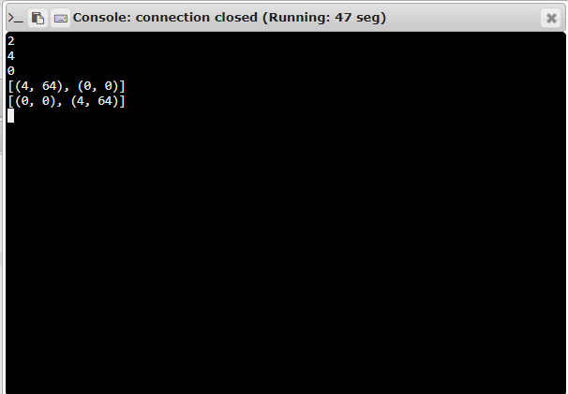

**Link:**

[**http://103.53.53.18/mod/vpl/forms/edit.php?id=317&userid=1708#**](http://103.53.53.18/mod/vpl/forms/edit.php?id=317&userid=1708#)

**RESULT:**

Successfully sorted in increasing order by the last element in each tuple from a given list of non-empty tuples.